ASSIGNMENT SET – 1

Assignment-1
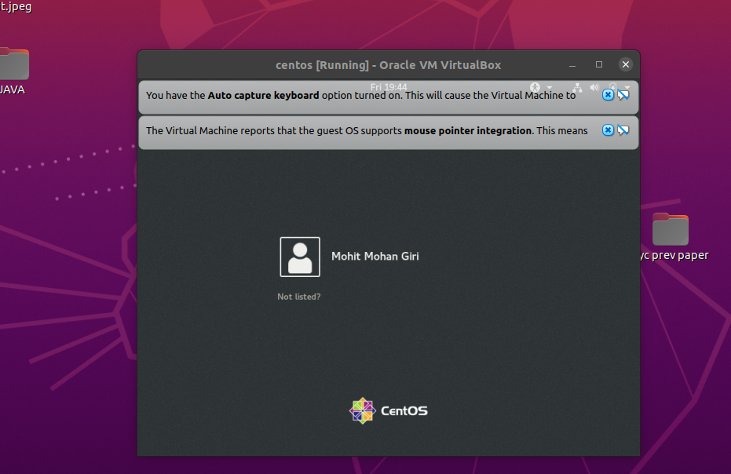
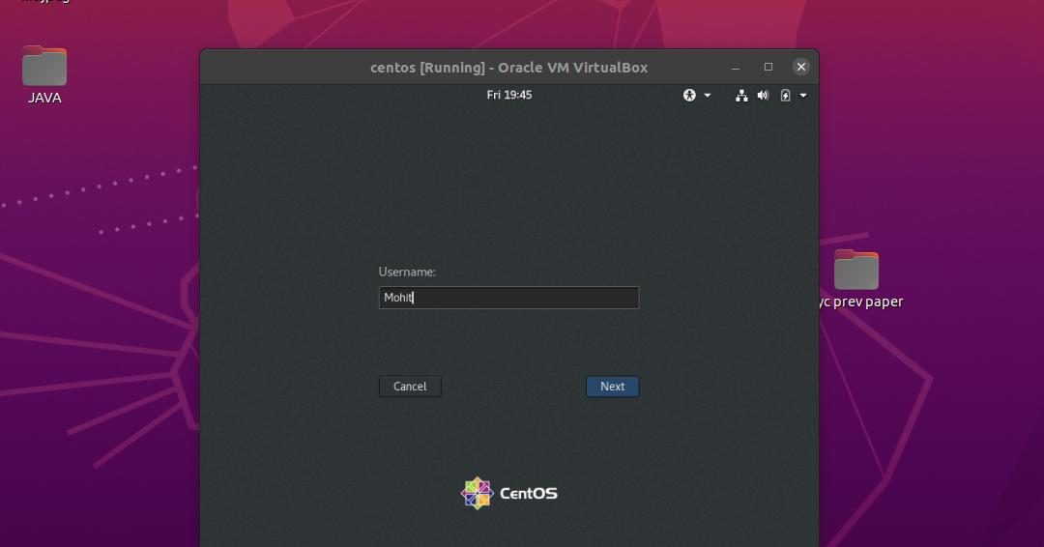
When I selected not listed? User it appered as the next windows follows:

when we provide a non-exixtent username. We cannot login to our system nither thorugh our own password nor by creating a seperate username password.

Assignment-2

Case – 1
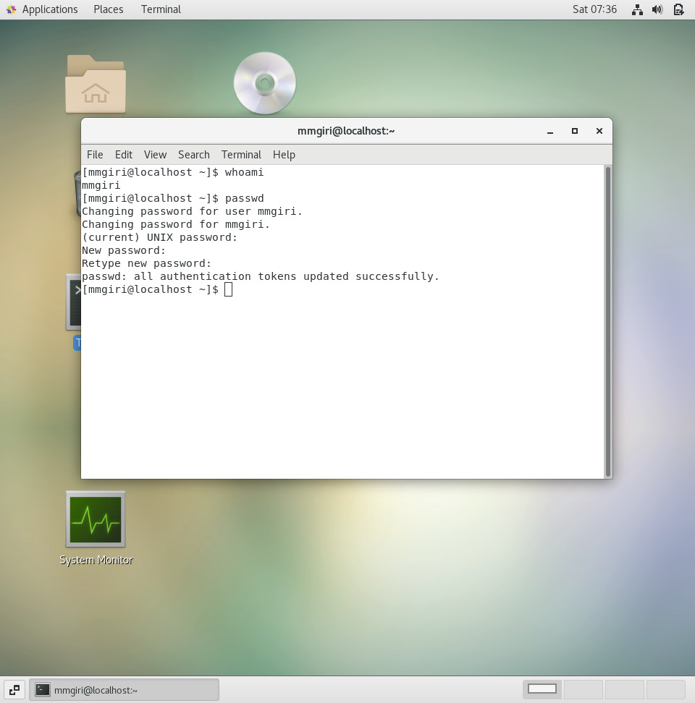
After writing passwd command it asks the current password, only after writting the correct password only it goes to for the changing to new password. So, in this case I changed my password to IneuR0n#42, and it was sucsessfully updated.

Case-2
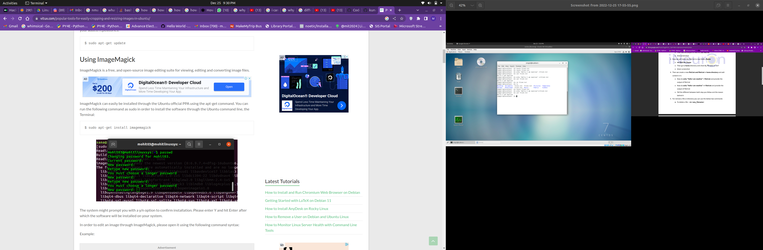

I tried password 1234 and abcd it poped up with a message on terminal as follows:
You must choose a long password

Case-3

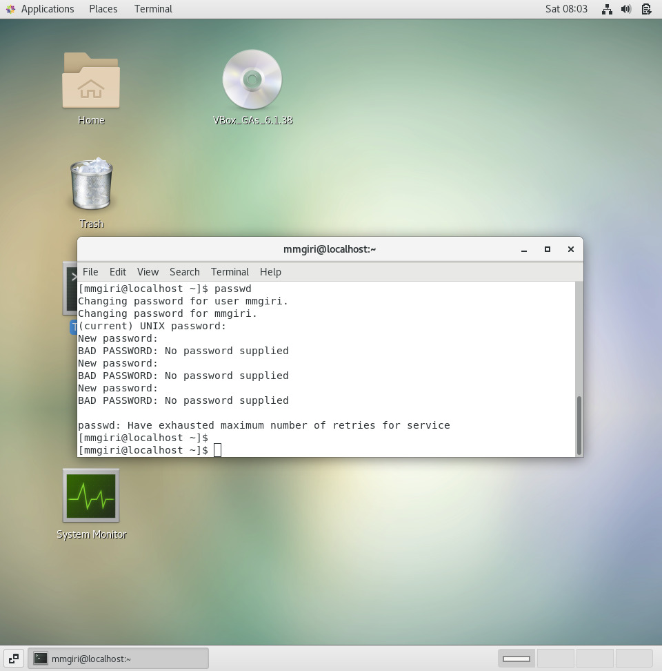

I tried password 1234 and abcd it poped up with a message on terminal as follows:
BAD PASSWORD: No password supplied.

Assignment-3

Q1)
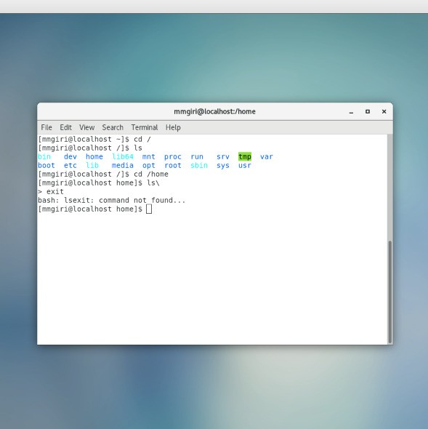

cd / - change directory to the root folder
and now
ls - lists the the directories inside the root folders.

Q2)
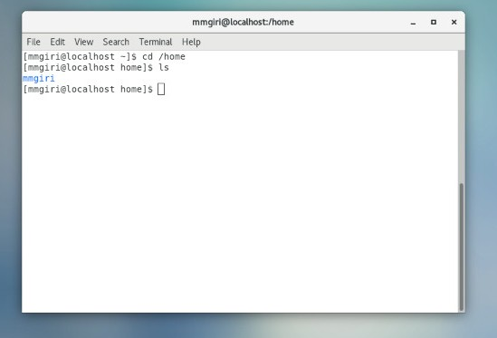

we changed directory to home from cd /home.
After ls – shows the users under home directory.

/home directory is used by the user it is the users space having Downloads , Document, Desktop, Music e.t.c

Q3)
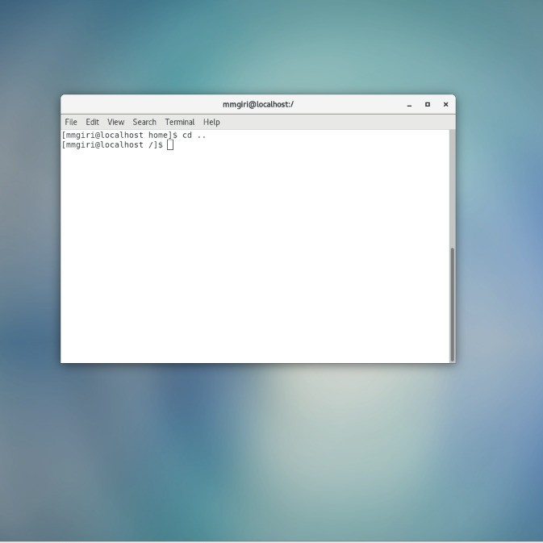

cd .. takes back to previous folder from the current directory in which the current directory is

Q4)

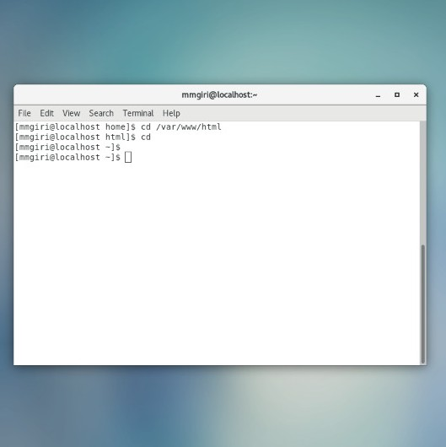

cd var/www/html changes the directory to this path as followed
and now
ls – lists nothing, it is empty, no directory.

Q5)

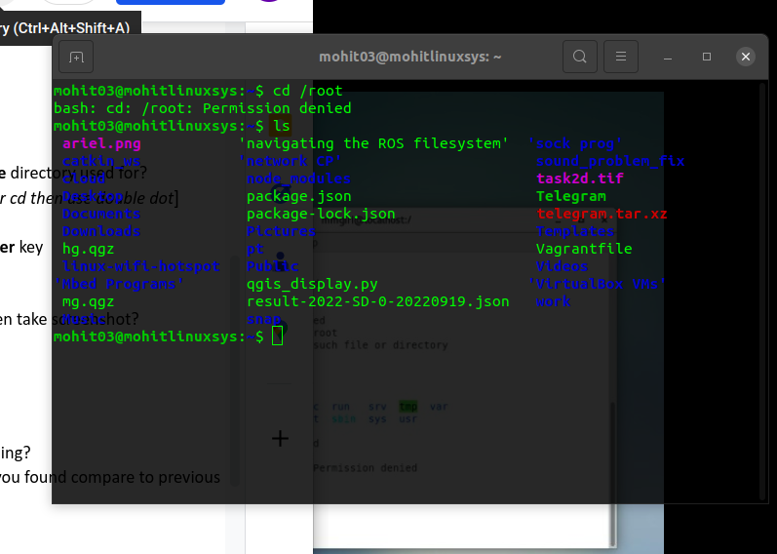
On typing cd /root it comes with a message that as follows:
bash: cd: /root: Permission denied
it denied to change the directory to root from home directory because the root folder is the top level and it starts with a ‘/’ ( known as root) under this root all directories of system comes.
and next
ls – lists all the directories within the home directory because on cd /root it doesn’t change the directory, as it remains in home directory it lists all the directory present within home.

Assignment-4

Q1)
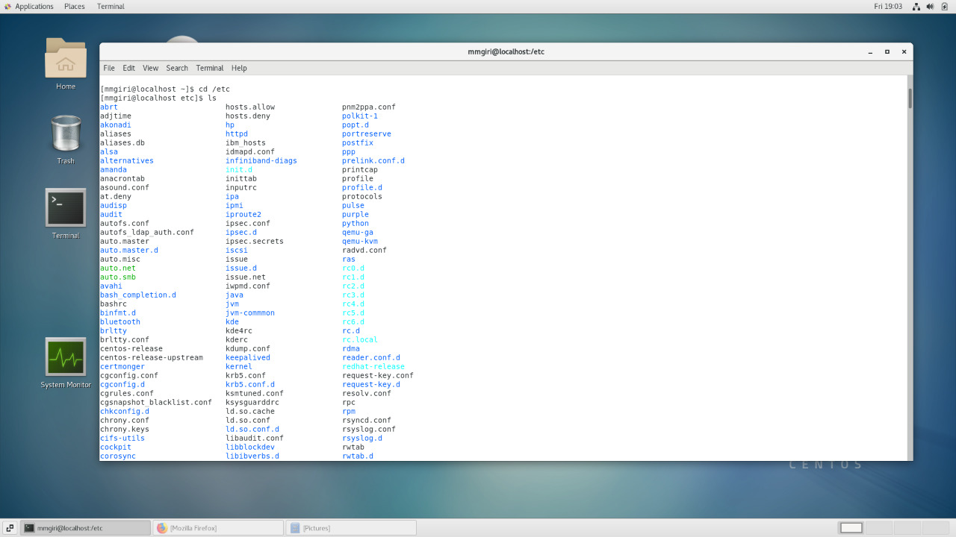

cd /etc – change the directory to the etc directory from home directory,
ls – lists all the directoried within etc directory.

Q2)
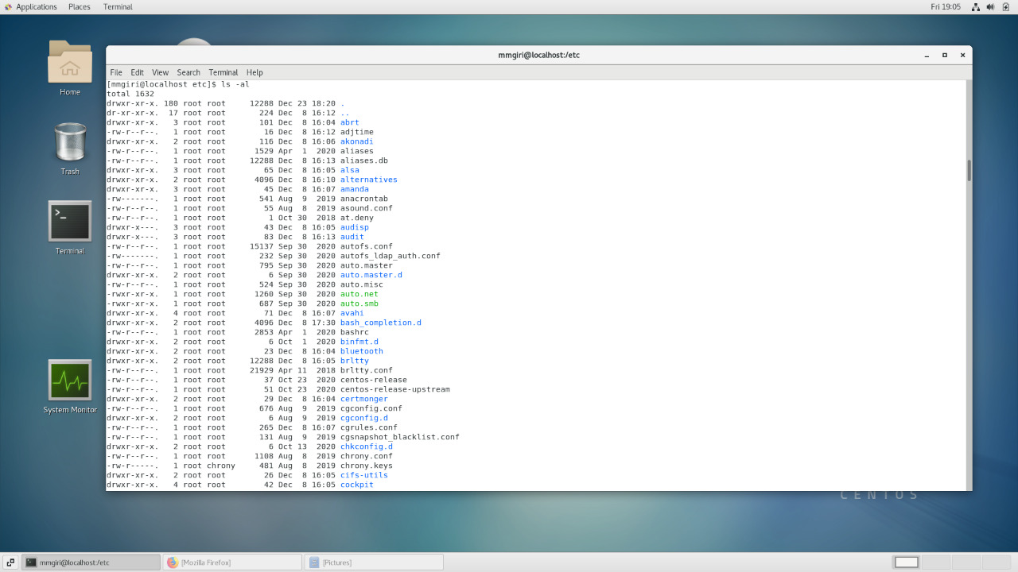

ls –al – it lists all the directories under it ,-al is abbrebriated as all, with permission, size and date and path

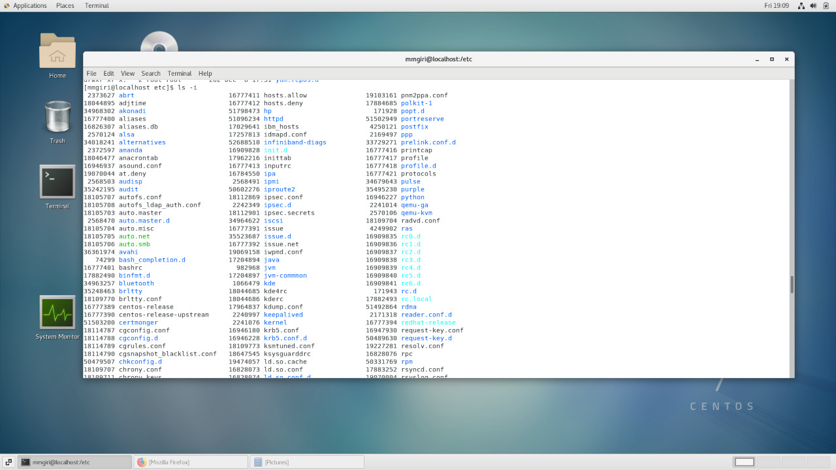
Q5)

ls -i -lists all the directories under the /etc drectories along with the index number.

Q6)
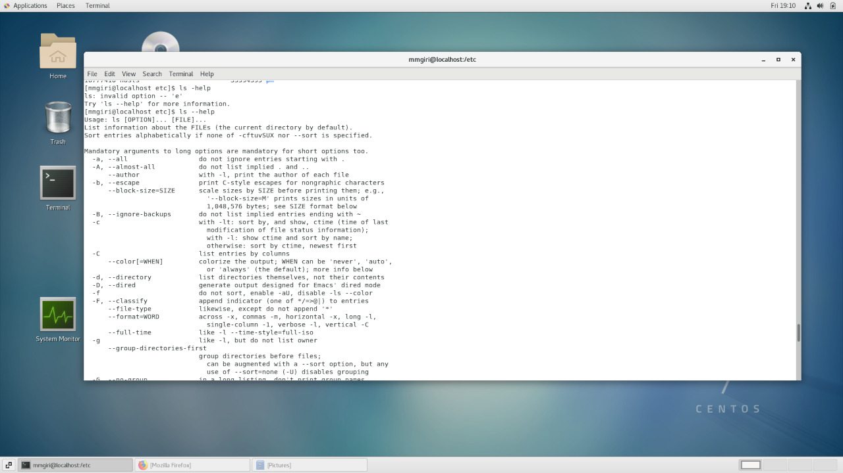
ls –help – it gives the discreption on the differnt arguments available to explore a instruction of command. We can try different argumnets with our command and see explore it in depth and more easy to use approach

Assignment-5

Q1)

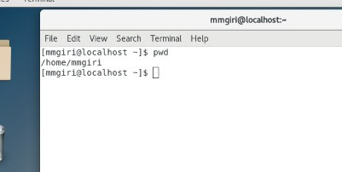

pwd – prints the current working directory that is home directory homemmgiri
Q3)

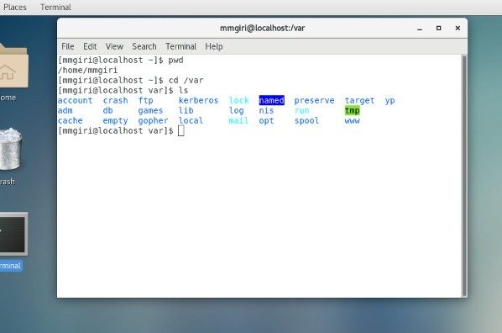
Here cd /var -change directory to var from etc
and using ls - lists all the directories under this directory.

